|  |  |
| --- | --- |
| TEAM ID | PNT2022TMID46309 |
| Project Name | IoT Based smart crop Protection system for agriculture |
| Maximum mark | 20 marks |

**SPRINT 4**

**STEP 1: MIT APP inventor to design the APP.**

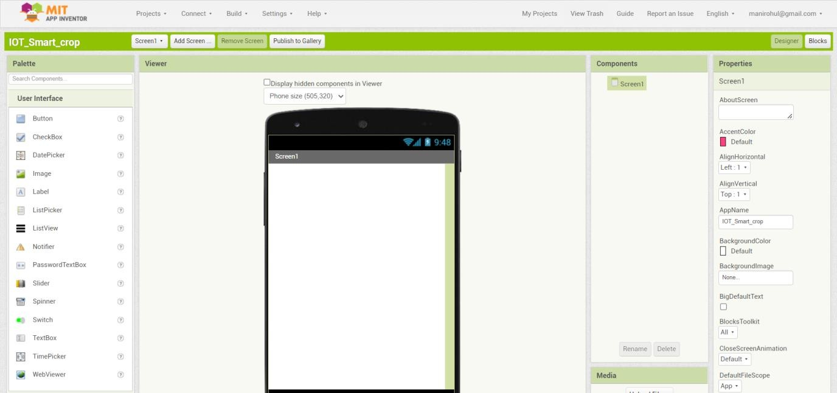

**STEP 2: Customize the App interface to Display the Values.**

